Sites / videos accessed for learning concepts
Code used from sites / videos
Code from Generative AI
Images

Sites / videos accessed for learning concepts

Site / video | Purpose

Code used from sites / videos

Site / video | Code used / why
https://www.pygame.org/docs/index.html | Code used for group collide so that the banana can collide and kill off spike and king spike  col_banana_spike=pygame.sprite.groupcollide(bananaGrp, spikeGrp, True, True), and king_col=pygame.sprite.groupcollide(kingspikeGrp, bananaGrp, False, True)  pygame.MOUSEBUTTONDOWN : for when the player left clicks to shoot a purple banana

Code from Generative AI

Generative AI Tool | Prompt, how code was used
N/A

Images

Site | Image (name or what it is)
https://twitter.com/GeometryInfo |   Used for spike and king spike
https://www.reddit.com/r/geometrydash/comments/15c0qtc/free_geometry_dash_wallpaper/ |   Cropped to make background
https://joke-battles.fandom.com/wiki/Urple_Banana?file=Urplebanana.jpg | 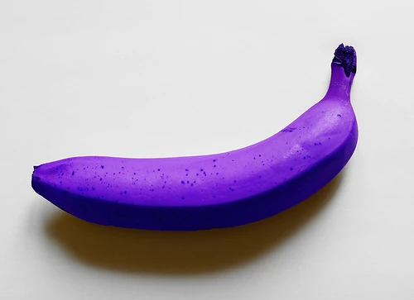  Used for purple banana
https://en.wikipedia.org/wiki/Heart_symbol |   Used for King spike health bar

